




EECE 202– Linear Circuit Analysis II
Spring 2026
Project Deliverable 1: Technical Report

Project Title: Industrial Load Analysis and Power Factor Improvement
Section Number: M4
Group Number: Group 4

Student ID | Student Name | Major | Section  Contribution
75018 | Yousef AlAbdulrazzaq | CE | 5, 6, 7
10094770 | Jamal AlEleawah | EE | 3, 4
10092588 | Salem AlDammaj | EE | 1, 2, 8

- Introduction
  - Problem Definition, Context & Objectives [PI1a]
Translating classroom theory into working engineering solutions is one of the most important skills a practising engineer can develop. In the electrical power domain, this means being able to look at a real facility—with its mix of motors, transformers, and driven loads—and quantify exactly how much power is being drawn, how efficiently it is being used, and what steps can be taken to improve that efficiency within the constraints of the utility supply.
This report presents a complete electrical and power analysis of the industrial load system installed in the new production wing of Apex Manufacturing. The facility introduces five categories of heavy electromechanical equipment connected in parallel to an AC utility supply characterized by:
$$v\left(t\right)=415\sin\left(377t\right)V$$
This gives a peak voltage of 415 V, an RMS voltage of 293.4 V, and an angular frequency ω = 377 rad/s (f ≈ 60 Hz). The local utility enforces power factor-based billing with penalty surcharges for poor power quality. The predominance of inductive loads introduces a large lagging reactive power component, reducing the system power factor and increasing apparent power demand and energy cost.

The five parallel loads, with G = 4 and S = 4 substituted into the impedance formulas, are:

Load | Type | Impedance (G=4, S=4)
IL₁ | Induction Motor | Z₁ = 6.2 + j4 Ω
IL₂ | Welding Machine | Z₂ = 3.4 + j5.4 Ω
IL₃ | Industrial Transformer | Z₃ = 0.9 + j0.6 Ω
IL₄ | Conveyor System Drive | Z₄ = 7.2 + j8 Ω
IL₅ | Air Compressor | Z₅ = 0.9 + j1.8 Ω

Objectives of this deliverable:
• Model the system as a parallel AC circuit and draw a labelled circuit diagram.
• Calculate branch currents and total source current using phasor analysis.
• Determine real power (P), reactive power (Q), apparent power (S), and power factor (PF) per load and for the overall system.
• Propose and design a shunt capacitor bank to improve the system PF by at least 5%.
• Recalculate and compare power quantities before and after compensation, and present power triangles for both cases.

- System Modeling [PI1b]
2.1. Electrical Circuit Model
The five industrial loads are connected in parallel between the supply terminals. Each load is modelled as a series R-L impedance of the form $Z=R+jX_{L}$. Since all reactances are positive (inductive), each branch is represented by a resistor R in series with an inductor L = X/ω. The equivalent inductance values at ω = 377 rad/s are:

Load | R (Ω) | Xₗ (Ω) | L = X/377 (mH)
IL₁ – Induction Motor | 6.2 | 4.0 | 10.61
IL₂ – Welding Machine | 3.4 | 5.4 | 14.32
IL₃ – Industrial Transformer | 0.9 | 0.6 | 1.59
IL₄ – Conveyor System Drive | 7.2 | 8.0 | 21.22
IL₅ – Air Compressor | 0.9 | 1.8 | 4.77

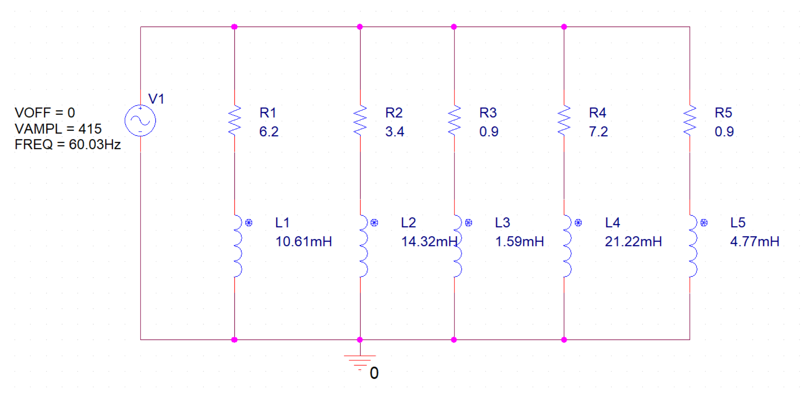
- Circuit Analysis [PI1b, PI1c]
Branch Current Calculations [5%]
Since all loads are in parallel, the same phasor voltage Vₛ = 293.4∠ 0° V (RMS) appears across every branch. The branch current is:
$$I_{n}=\frac{V_{s}}{Z_{n}}$$
IL₁ (Induction Motor):
Z₁ = 6.2 + j4 Ω
|Z₁| = √(6.2² + 4²) = √54.44 = 7.378 Ω θ₁ = arctan(4/6.2) = 32.8°
I₁ = 293.4 / 7.378 ∠−32.8° = 39.77∠−32.8° A

IL₂ (Welding Machine):
Z₂ = 3.4 + j5.4 Ω
|Z₂| = √(3.4² + 5.4²) = √40.72 = 6.381 Ω θ₂ = arctan(5.4/3.4) = 57.8°
I₂ = 293.4 / 6.381 ∠−57.8° = 45.97∠−57.8° A

IL₃ (Industrial Transformer):
Z₃ = 0.9 + j0.6 Ω
|Z₃| = √(0.9² + 0.6²) = √1.17 = 1.082 Ω θ₃ = arctan(0.6/0.9) = 33.7°
I₃ = 293.4 / 1.082 ∠−33.7° = 271.2∠−33.7° A

IL₄ (Conveyor System Drive):
Z₄ = 7.2 + j8 Ω
|Z₄| = √(7.2² + 8²) = √115.84 = 10.763 Ω θ₄ = arctan(8/7.2) = 48.0°
I₄ = 293.4 / 10.763 ∠−48.0° = 27.26∠−48.0° A

IL₅ (Air Compressor):
Z₅ = 0.9 + j1.8 Ω
|Z₅| = √(0.9² + 1.8²) = √4.05 = 2.012 Ω θ₅ = arctan(1.8/0.9) = 63.4°
I₅ = 293.4 / 2.012 ∠−63.4° = 145.8∠−63.4° A

Total Source Current Calculations [5%]
Converting each branch current to rectangular form and summing:

Load | $I_{real}$(A) | $I_{imaginary}$ (A)
IL₁ | 39.77 × cos 32.8° = 33.40 | −39.77 × sin 32.8° = −21.60
IL₂ | 45.97 × cos 57.8° = 24.49 | −45.97 × sin 57.8° = −38.88
IL₃ | 271.2 × cos 33.7° = 225.60 | −271.2 × sin 33.7° = −150.20
IL₄ | 27.26 × cos 48.0° = 18.23 | −27.26 × sin 48.0° = −20.26
IL₅ | 145.8 × cos 63.4° = 65.28 | −145.8 × sin 63.4° = −130.40
Σ Total | 367.0 A | −361.3 A

|Iₛ| = √(367.0² + 361.3²) = √265,227 = 515.0 A
θₛ = arctan(−361.3 / 367.0) = −44.5°
Iₛ = 515.0∠−44.5° A

- Power Analysis [PI1b & PI1c]
4.1. Power Consumed by Each Load & Power Factor [10%]
For each load: $P_{n}={\left|I_{n}\right|}^{2}R_{n} , Q_{n}={\left|I_{n}\right|}^{2}X_{n} , S_{n}=\sqrt{{P_{n}}^{2}+{Q_{n}}^{2}} , {PF}_{n}=cosθ_{n}$

Load | P (W) | Q (VAR) | S (VA) | PF
IL₁ | 39.77² × 6.2 = 9,802 | 39.77² × 4 = 6,324 | 11,671 | 0.840 lag
IL₂ | 45.97² × 3.4 = 7,189 | 45.97² × 5.4 = 11,421 | 13,459 | 0.533 lag
IL₃ | 271.2² × 0.9 = 66,208 | 271.2² × 0.6 = 44,139 | 79,476 | 0.832 lag
IL₄ | 27.26² × 7.2 = 5,350 | 27.26² × 8 = 5,944 | 7,973 | 0.669 lag
IL₅ | 145.8² × 0.9 = 19,135 | 145.8² × 1.8 = 38,270 | 42,833 | 0.447 lag

4.2. Overall System Power & Power Factor [5%]
$$P_{total}=9,802 + 7,189 + 66,208 + 5,350 + 19,135 = 107,684 W ≈ 107.7 kW$$
$$Q_{total}=6,324 + 11,421 + 44,139 + 5,944 + 38,270 = 106,098 VAR ≈ 106.1 kVAR$$
$$S_{total}=V_{S}I_{S}=293.4 × 515.0 = 151,101 VA ≈ 151.1 kVA$$
${PF}_{system}=\frac{P}{S}=\frac{107,684 }{151,101}=0.713 lagging (θ=44.5$)
- Power Factor Improvement [PI1b, PI1c]
5.1. Propose a Power Factor Correction Method [15%]
The original PF of 0.713 is below utility requirements. The proposed correction is to connect a shunt capacitor bank in parallel with the existing load bank. A capacitor supplies leading reactive power (negative Q), which partially cancels the lagging reactive power of the inductive loads, reducing Qₜₒₜₐₗ and raising the power factor without changing the active power P.
Target: ${PF}_{target}$ = 0.95 lagging.

Capacitor design:
Step 1 – Required capacitive reactive power Qᶜ:
$$θ_{1}=\arccos\left(0.713\right)=44.5°→ Q_{1}=P\tan\left(44.5°\right)=107,684*0.985=106,098 VAR$$
$$θ_{2}=\arccos\left(0.95\right)=18.2°→ Q_{2}=P\tan\left(18.2°\right)=107,684*0.329=35.428 VAR$$
$$Q_{C}=Q_{1}-Q_{2}=106,098-35,428=70,670 VAR ≈70.7 kVAR$$

Step 2 – Capacitor reactance and value:
$$Q_{c}=\frac{V_{rms}^{2}}{X_{C}}→ X_{C}=\frac{V_{rms}^{2}}{Q_{C}}= \frac{{293.4}^{2}}{70,670}=1.218Ω$$
$$C=\frac{1}{ωX_{C}}=\frac{1}{377*1.218}=\frac{1}{459.2}=2.18mF$$
A capacitor of C = 2.18 mF is connected in parallel with the five loads.

5.2. Compensated Circuit Diagram and Full Analysis [15%]
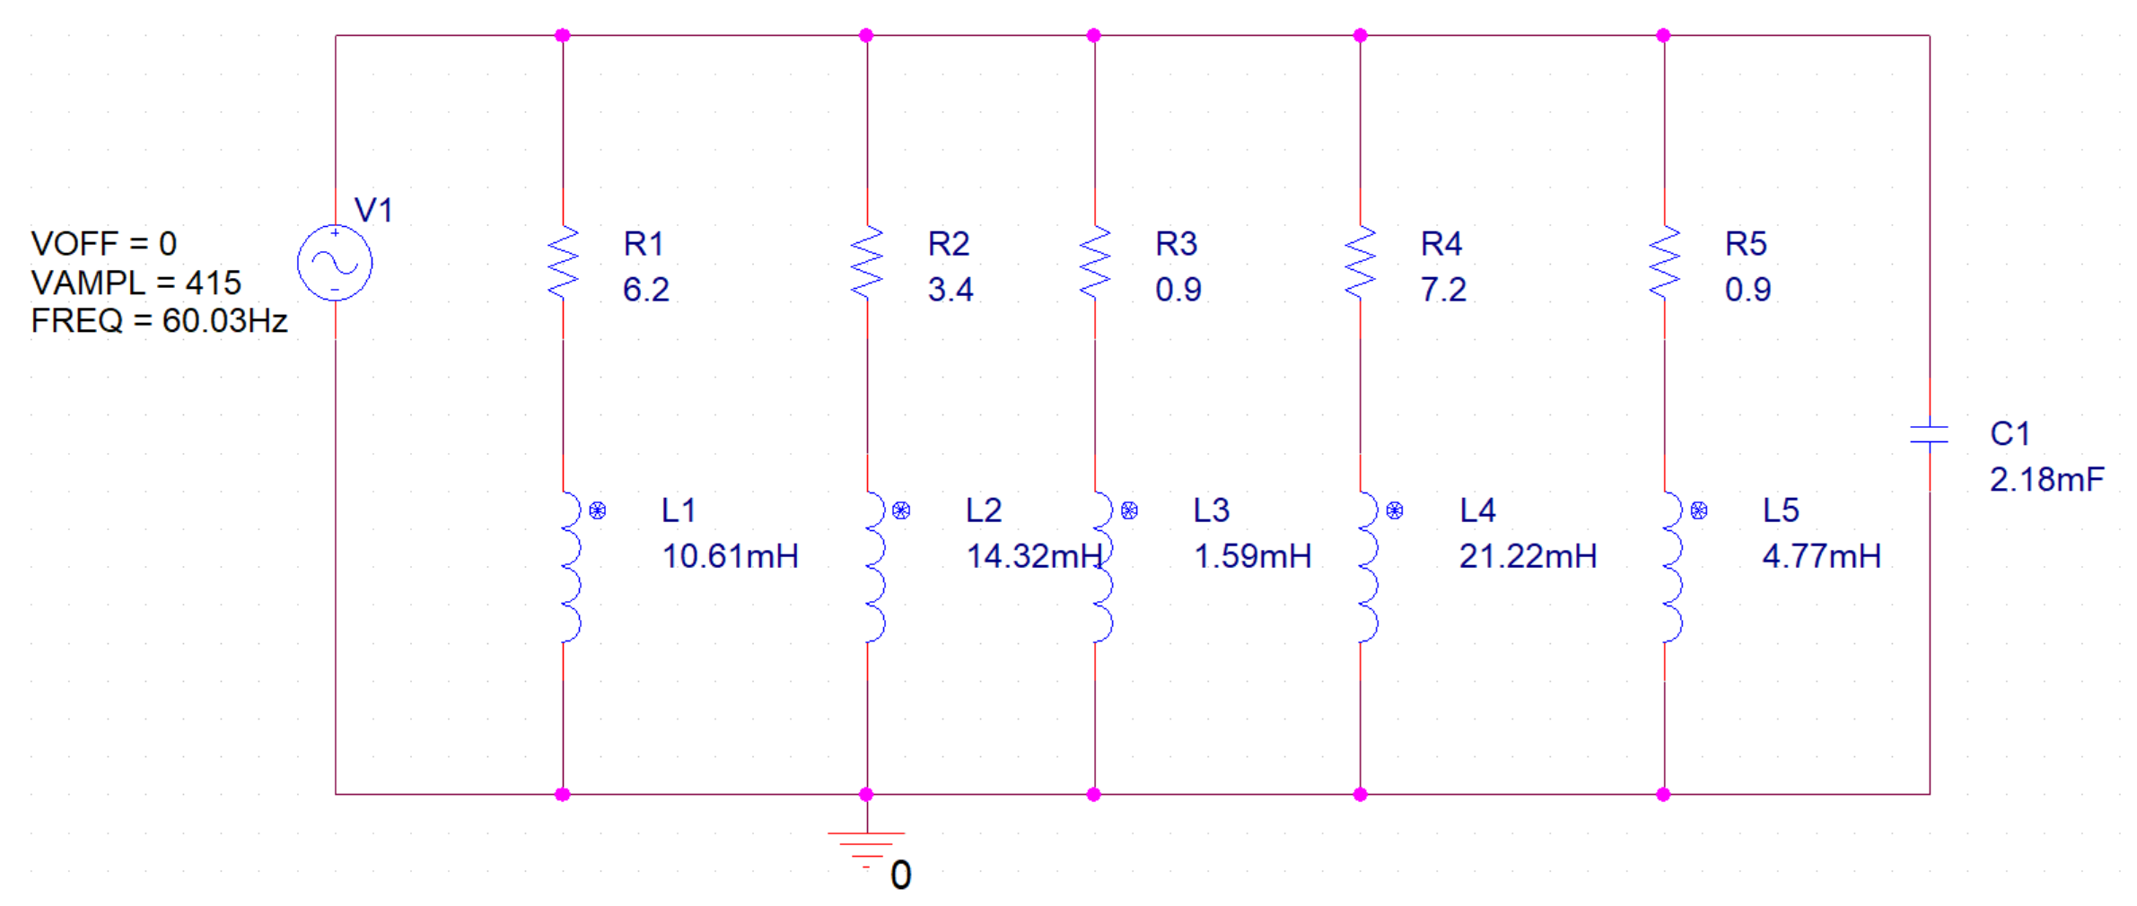
Added component: C = 2.18mF connected in parallel with the five loads.
Capacitor reactance: $X_{C}=\frac{1}{ωC}=\frac{1}{377*0.00218}=1.218Ω$
Capacitor current: $I_{C}=\frac{V_{rms}}{X_{C}}=\frac{293.4}{1.218}=240.9∠90° A (leading)$
This purely capacitive current supplies leading reactive power that directly cancels a portion of the lagging reactive current from the inductive loads.
- Power Analysis for the Compensated System [PI1c]
6.1. Recalculated Power Values

Total active power (unchanged):
Pₜₒₜₐₗ = 107,684 W ≈ 107.7 kW
Active power is unaffected by a purely reactive element.

Total reactive power after compensation:

$Q_{new}=Q_{original}-Q_{C}$ = 106,098 − 70,670 = 35,428 VAR ≈ 35.4 kVAR

Total apparent power after compensation:
$S_{new}=\sqrt{P^{2}+Q_{new}^{2}}$ = √(107,684² + 35,428²) = √12,850,779,240 ≈ 113,363 VA ≈ 113.4 kVA

Power factor after adding the component:
${PF}_{new}=\frac{P}{S_{new}}$= 107,684 / 113,363 = 0.950 lagging (θ = 18.2°)

New source current (for reference):
${I_{S}}_{new}= \frac{S_{new}}{V_{S}}$ = 113,363 / 293.4 = 386.5 A (reduced from 515.0 A)

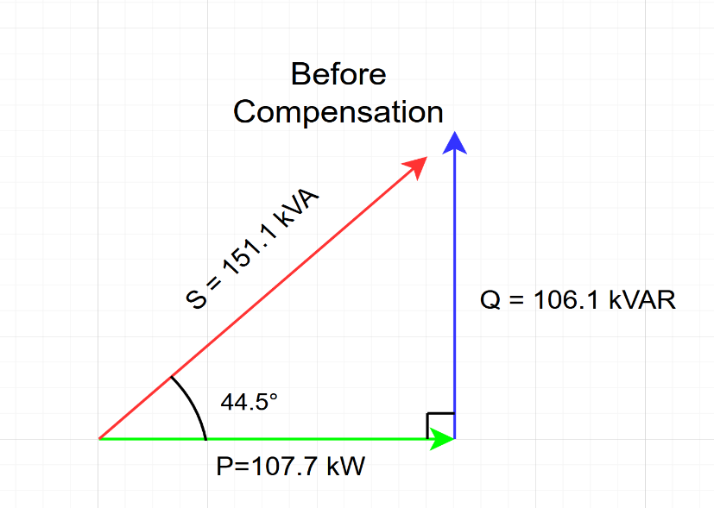
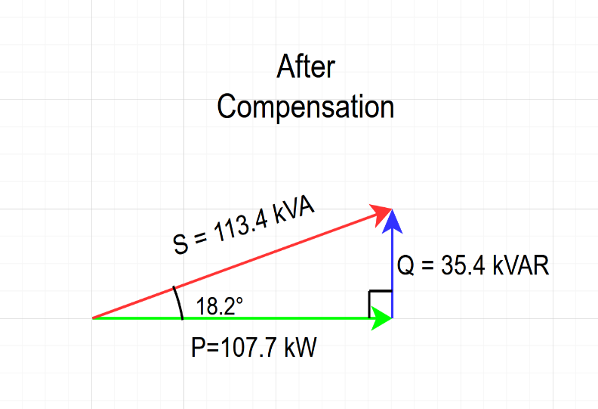
6.2. Power Triangle Diagrams

- Summary of Results

Parameter | Original System | Compensated System
Vₛ | 293.4 | 293.4
Iₛ | 515.0∠−44.5° | 386.5∠−18.2°
I₁ – IL₁ | 39.77∠−32.8° A | —
I₂ – IL₂ | 45.97∠−57.8° A | —
I₃ – IL₃ | 271.2∠−33.7° A | —
I₄ – IL₄ | 27.26∠−48.0° A | —
I₅ – IL₅ | 145.8∠−63.4° A | —
Pₜₒₜₐₗ (kW) | 107.7 | 107.7
Qₜₒₜₐₗ (kVAR) | 106.1 | 35.4
Sₜₒₜₐₗ (kVA) | 151.1 | 113.4
System PF | 0.713 lagging | 0.950 lagging
Phase angle θ | 44.5° | 18.2°
Capacitor C | — | 2.18 mF
$Q_{C}$ supplied (kVAR) | — | 70.7

- Conclusion
This report presented a complete AC phasor analysis of the industrial load system at Apex Manufacturing’s new production wing. The five parallel industrial loads, supplied by v(t) = 415 sin(377t) V, were modelled using their complex impedances with G = 4 and S = 4 substituted.

The analysis determined a total source current of 515.0∠−44.5° A, with a system active power of 107.7 kW, reactive power of 106.1 kVAR, apparent power of 151.1 kVA, and a lagging power factor of 0.713. This poor power factor would result in utility penalty charges.

A shunt capacitor bank of C = 2.18 mF was designed and connected in parallel with the load bank. This supplies 70.7 kVAR of leading reactive power, reducing the total reactive power demand to 35.4 kVAR, improving the apparent power to 113.4 kVA, and raising the system power factor to 0.950 lagging – a significant improvement that brings the facility within utility compliance limits, reduces the source current by approximately 25%, and lowers the overall energy cost.

